Name:

ID:

M3 Review 2

<https://repl.it/@enaard/Python-3>

1) Which python function is used for getting information out of the program?

|  |  |
| --- | --- |
| Input | Type |
| out | output |
| enter | print |

2) Which of the following is a dictionary?

|  |  |
| --- | --- |
| z = lambda a,b: a + b | ([],[]) |
| [{}] | (1,2,[2]) |
| {“z”:None} | [True, [1,2]] |

3) What is the output?

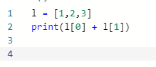

4) Which of the following best describes the modulo operator?

|  |  |
| --- | --- |
| Adds binary numbers | Remainder from division |
| Divides integers | Floor division |
| Gives decimals of a number | Percentage |

5) Consider the following:

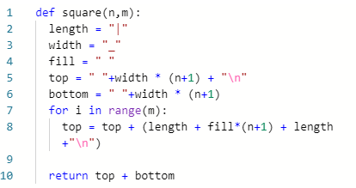

* How many parameters does the square function have?
* How many assignment operations occur inside of this function?

6) What is the value of L?

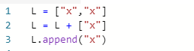

|  |  |
| --- | --- |
| “x” | [“x”] |
| “xx” | ‘xxxx’ |
| [“x”,”x”] | [‘x’,”x”,’x’] |
| “xxx” | [] |
| [“x”,[“x”,”x”,”x”]] | [‘x’,’x’,’x’,’x’] |

7) What is the last element of range(2) plus the first element of range(7)?

|  |  |
| --- | --- |
| range(0,5) | ‘e’ |
| 0 | 5 |
| 4 | 1 |

8) What is the data type of a+b+c?

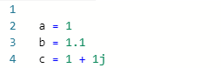

|  |  |
| --- | --- |
| complex | float |
| list | boolean |
| dictionary | number |

9) What is the difference between one equal sign and two equal signs in python?

10) What is the output?



11) Which of the following has a Boolean value?

|  |  |
| --- | --- |
| “True” | “””False””” |
| 1 + 1 | 0 |
| ‘False’ | 1 > 0 |

12) What is the output?

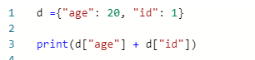

13) Complete the following table:

|  |  |
| --- | --- |
| Data Type | Example |
| Integer | 1 |
|  | ‘azz’ |
|  | 0.666 |
|  | [1,”a”,[]] |
|  | True and 1> 0 |
|  | 1 + 2j |
|  | {“a”: [1,2,3,4,”5”]} |

14) How many assignment operations occur?

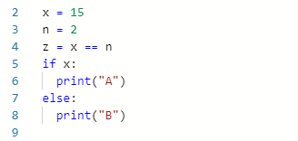

15) What value of **x** will make the output “even”?

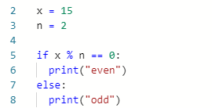

16) Find values of A,B, and C so the output is “A”:

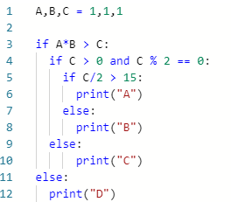

17) Consider the following function:

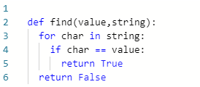

* How many parameters?
* Is the function fruitful or a procedure?
* How many assignment operations?
* What is the output of **find(“a”,”aslhgfjfvkjsdfkfsddfhhbjbhjsdf”)**?

18) Consider the following:

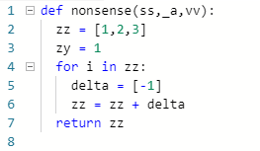

* How many parameters does the function have?
* What is the name of the function?
* What are the names of the lists in this function?
* Is the function fruitful or a procedure?

19) Design a function named **my_sum** with two parameters **a** and **b**. It should return the sum of these parameters.